**INTRODUCTION TO COMPELX SIGNALS IN MATLAB**

**LAB # 05**



**Spring 2022**

**CSE301L Signals & Systems Lab**

Submitted by: **Ebtihaj Abdullah**

Registration No. : **20PWCSE1885**

Class Section: **A**

“On my honor, as student of University of Engineering and Technology, I have neither given nor received unauthorized assistance on this academic work.”

Student Signature: ______________

Submitted to:

**Engr. Durr-e-Nayab**

Friday, May 31, 2022

**Department of Computer Systems Engineering**

**University of Engineering and Technology, Peshawar**

## Lab Objective(s):

Objectives of this Lab are;

* Gain familiarity with Complex Numbers and plot them
* Complex exponential signals
* Real exponential signals

## Task # 01:

Write matlab function zprint, which takes a complex number and returns it real part, imaginary

part, magnitude, phase in radians, and phase in degrees.

A sample run of program is:

>> zprint(z)

Z = X + jY Magnitude Phase Ph(deg)

3 4 5 0.927 53.13

**Problem Analysis:**

Complex analysis is neede for complex calculation. Here we analyze a complex number.

**Algorithm:**

* Enter the complex Number
* Print using zprint

**Code:**

*t=0:0.04:4;*

*A=3;*

*pi=0.4;*

*w=2*pi*(1250);*

*x=A*exp(i*w*t+pi);*

*figure(1)*

*plot(t,real(x),'-m')*

*title('Real part')*

*xlabel('Sample Number')*

*ylabel('Signal Amplitude')*

*figure(2)*

*plot(t,imag(x),'-m')*

*title('Imaginary part')*

*xlabel('Sample number')*

*ylabel('Signal Amplitude')*

*figure(3)*

*subplot(2,1,1)*

*plot(t,real(x),'-m')*

*title('Real part')*

*xlabel('Sample Number')*

*ylabel('Signal Amplitude')*

*subplot(2,1,2)*

*plot(t,imag(x),'-m')*

*title('Imaginary part')*

*xlabel('Sample number')*

*ylabel('Signal Amplitude')*

**Code SS:**

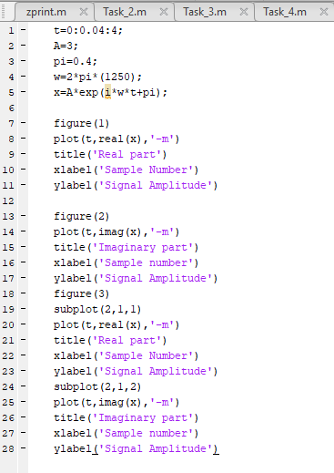

**Output / Graphs / Plots / Results:**

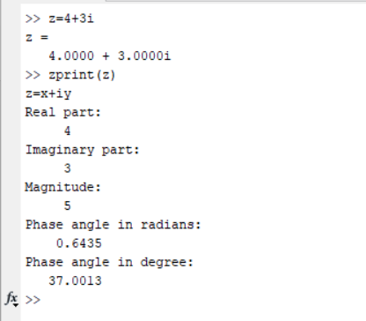

**Discussion and Conclusion:**

MATLAB can analyze a complex number.

## Task # 02:

Compute the conjugate ź (i.e. z_conj [give variable name]) and the inverse 1/z (i.e. z_inv [give

variable name]) for any complex number z. Display the results numerically with zprint.

**Problem Analysis:**

Complex analysis is neede for complex calculation. Here we analyze a complex number.

**Algorithm:**

* Enter the complex Number
* Print using zprint

**Code:**

*function Task_2(comp)*

*disp('z=x+iy');*

*disp('Real part:');*

*disp(real(comp));*

*disp('Imaginary part:');*

*disp(imag(comp));*

*disp('Magnitude:')*

*disp(abs(comp));*

*disp('Phase angle in radians:');*

*disp(angle(comp));*

*disp('Phase angle in degree:');*

*disp(angle(comp)*57.5);*

*[conj_z,inverse]=conjugate2(comp)*

*disp('Conjugate:')*

*disp(conj_z)*

*disp('Inverse:')*

*disp(inverse)*

**Code SS:**

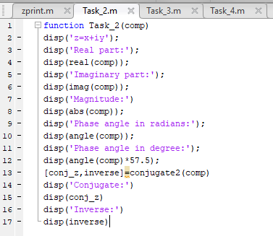

**Output / Graphs / Plots / Results:**

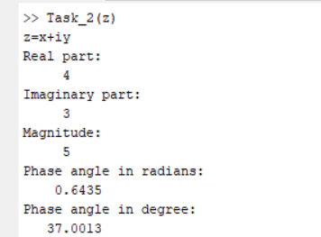

**Discussion and Conclusion:**

MATLAB can analyze a complex number.

## Task # 03:

Take two complex number and compute z1 +z2 and display the results numerically using zprint.

**Problem Analysis:**

Complex operation is needed for complex calculation. Here we operate on a complex number.

**Algorithm:**

* Enter the complex Numbers
* Add them
* Print using zprint

**Code:**

*x1=2+3i;*

*x2=3+4i;*

*x=x1+x2;*

*zprint(x);*

**Code SS:**

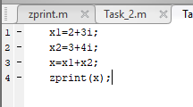

**Output / Graphs / Plots / Results:**

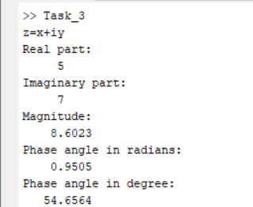

**Discussion and Conclusion:**

MATLAB can analyze as well compute a complex number.

## Task # 04:

Take two complex numbers and compute z1z2 and z1/z2. Use zprint to display the results

numerically.

**Problem Analysis:**

Complex operation is needed for complex calculation. Here we operate on a complex number.

**Algorithm:**

* Enter the complex Numbers
* Multiply and divide them
* Print using zprint

**Code:**

*z1=3+4i;*

*z2=4+5i;*

*z3=z1*z2;*

*z4=z1/z2;*

*disp('Multiplied comp. number');*

*zprint(z3);*

*disp('Divided comp. number');*

*zprint(z4);*

**Code SS:**

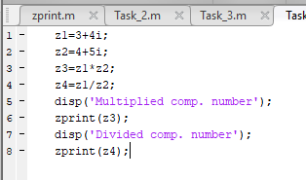

**Output / Graphs / Plots / Results:**

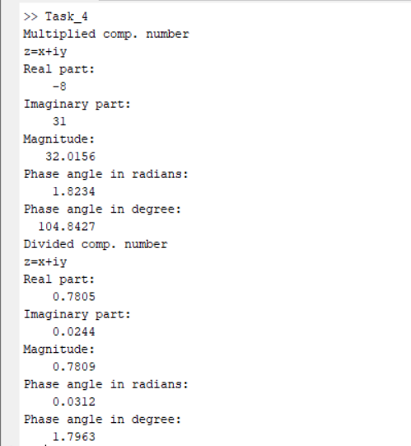

**Discussion and Conclusion:**

MATLAB can analyze as well compute a complex number.

## Task # 05:

Determine the complex conjugate of the exponential signal given in above example and plot its

real and imaginary portions.

**Problem Analysis:**

Complex operation is needed for complex calculation. Here we operate on a complex number.

**Algorithm:**

* Enter the complex number
* Find the conjugate
* Print it

**Code:**

*t=1:0.5:10;*

*angle=pi/2;*

*Amp=5;*

*x=Amp*exp(angle*t*i);*

*x_conj=conj(x)*

*subplot(2,2,1)*

*stem(t,real(x),'-m');*

*title('Real part');*

*xlabel('Sample Number')*

*ylabel('Signal Amplitude')*

*subplot(2,2,2)*

*stem(t,real(x_conj),'-m');*

*title('Real part of complex conjugate');*

*xlabel('Sample Number')*

*ylabel('Signal Amplitude')*

*subplot(2,2,3)*

*stem(t,imag(x),'-m');*

*title('Imaginary part');*

*xlabel('Sample Number')*

*ylabel('Signal Amplitude')*

*subplot(2,2,4)*

*stem(t,imag(x_conj),'-m');*

*title('Imaginary part of complex conjugate');*

*xlabel('Sample Number')*

*ylabel('Signal Amplitude')*

**Code SS:**

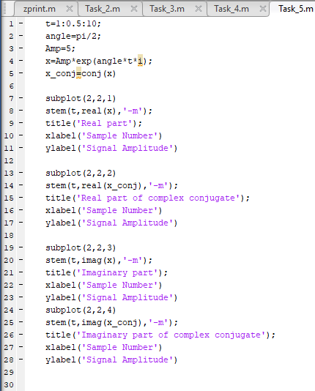

**Output / Graphs / Plots / Results:**

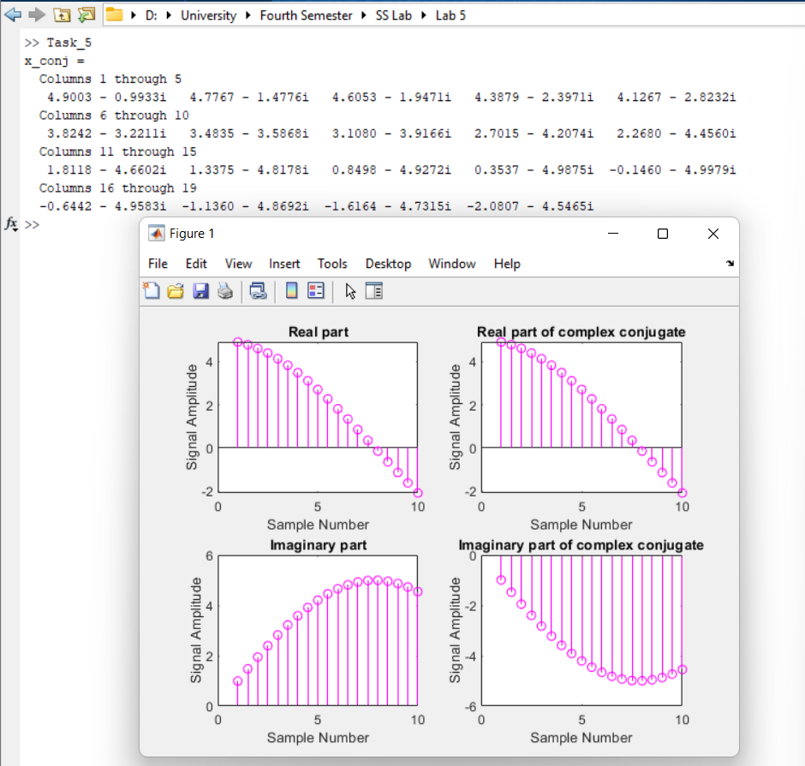

**Discussion and Conclusion:**

MATLAB can analyze as well compute a complex number.

## Task # 06:

Generate the complex valued signal and plot its magnitude, phase, the real part, and the

imaginary part in separate subplots.

y(n) = exp (-0.2 + j0.5n) , ‐10≤n≤10

**Problem Analysis:**

Complex operation as well as visualization is needed for complex calculation. Here we operate on a complex number.

**Algorithm:**

* Enter the complex number
* Plot its parameters

**Code:**

*t=-10:0.1:10;*

*x=exp(-0.2+i*0.5*t);*

*subplot(4,1,1)*

*stem(t,abs(x),'filled');*

*title('Magnitude');*

*xlabel('Sample Number')*

*ylabel('Signal Amplitude')*

*subplot(4,1,2)*

*stem(t,real(x),'filled');*

*title('Real part');*

*xlabel('Sample Number')*

*ylabel('Signal Amplitude')*

*subplot(4,1,3)*

*stem(t,imag(x),'filled');*

*title('Imaginary part');*

*xlabel('Sample Number')*

*ylabel('Signal Amplitude')*

*subplot(4,1,4)*

*stem(t,angle(x),'filled');*

*title('Phase');*

*xlabel('Sample Number')*

*ylabel('Signal Amplitude')*

**Code SS:**

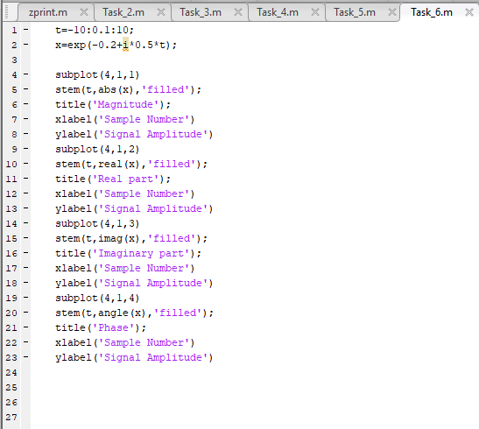

**Output / Graphs / Plots / Results:**

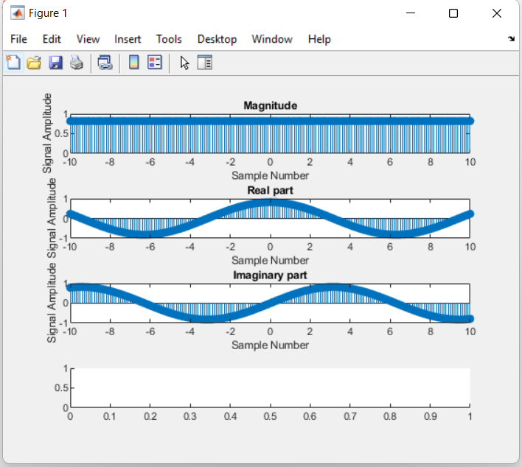

**Discussion and Conclusion:**

MATLAB can analyze as well visualize a complex number.

## Task # 07:

a) Generate a real‐exponential x=a * exp (n) for a=0.7 and n ranging from 0‐10. Find the

discrete time as well as the continuous time version of this signal. Plot the two signals on

same graph (holding both the graphs).

b) Repeat the same program with value of a=1.3.

**Problem Analysis:**

Exponential signal is used in various signal systems. We work with exponential signals in MATLAB.

**Algorithm:**

* Enter a exponential signal
* Plot its discrete as well as its continuous function

**Code:**

*n=0:10;*

*a1=0.7;*

*a2=1.3;*

*x1=power(a1,n);*

*x2=power(a2,n);*

*subplot(4,1,1)*

*stem(n,x1,'filled')*

*title('Real of discrete time signal(For a=0.7)')*

*xlabel('Sample Number')*

*ylabel('Signal Amplitude')*

*subplot(4,1,2)*

*plot(n,x1,'-m')*

*title('Real of continuous time signal(For a=0.7)')*

*xlabel('Sample Number')*

*ylabel('Signal Amplitude')*

*subplot(4,1,3)*

*stem(n,x2,'filled')*

*title('Real of discrete time signal(For a=1.3)')*

*xlabel('Sample Number')*

*ylabel('Signal Amplitude')*

*subplot(4,1,4)*

*plot(n,x2,'-m')*

*title('Real of continuous time signal(For a=1.3)')*

*xlabel('Sample Number')*

*ylabel('Signal Amplitude')*

**Code SS:**

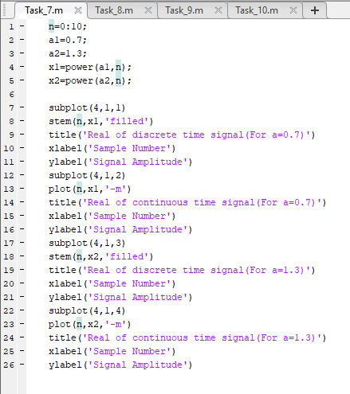

**Output / Graphs / Plots / Results:**

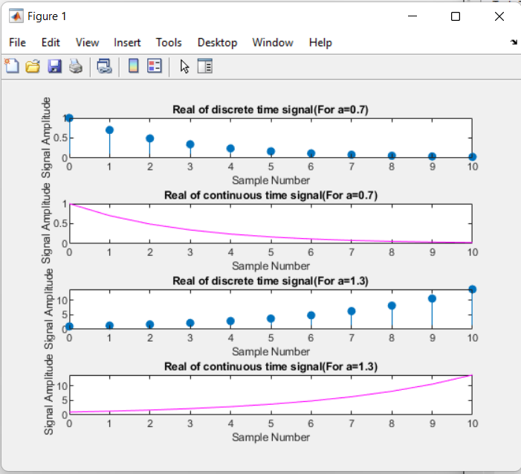

**Discussion and Conclusion:**

MATLAB can analyze as well visualize a complex number.

## Task # 08:

Multiply the two discrete signals x1=5 exp(i*n*pi/4) and x2= a * exp(n) (use point‐by‐point multiplication of the two signals). Plot the real as well as the exponential parts for 0<a<1 and a>1.

**Problem Analysis:**

We require exponential signal calculations in Signal and Systems. Here we use MATLAB to perform that.

**Algorithm:**

* Enter two exponential signals
* Multiply them

**Code:**

*n=0:0.1:10;*

*a1=0.5;*

*a2=2;*

*x1=5*exp(i*n*pi/4);*

*x2=power(a1,n);*

*x3=x1.^x2;*

*x2_2=power(a2,n);*

*x3_2=x1.^x2_2;*

*subplot(2,2,1)*

*stem(n,real(x3),'filled')*

*title('Real part for 0<a<1')*

*subplot(2,2,2)*

*stem(n,imag(x3),'filled')*

*title('Imaginary part for 0<a<1')*

*subplot(2,2,3)*

*stem(n,real(x3_2),'filled')*

*title('Real part for a>1')*

*subplot(2,2,4)*

*stem(n,imag(x3_2),'filled')*

*title('Imaginary part for a>1')*

**Code SS:**

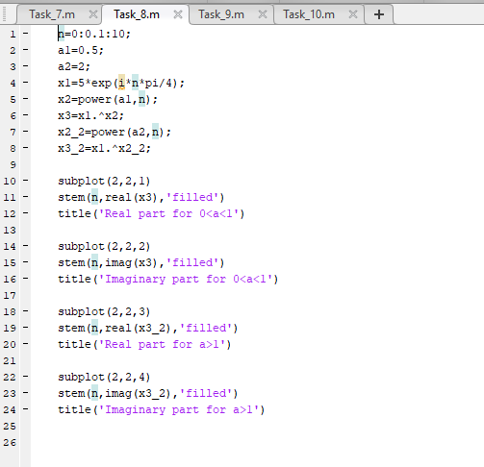

**Output / Graphs / Plots / Results:**

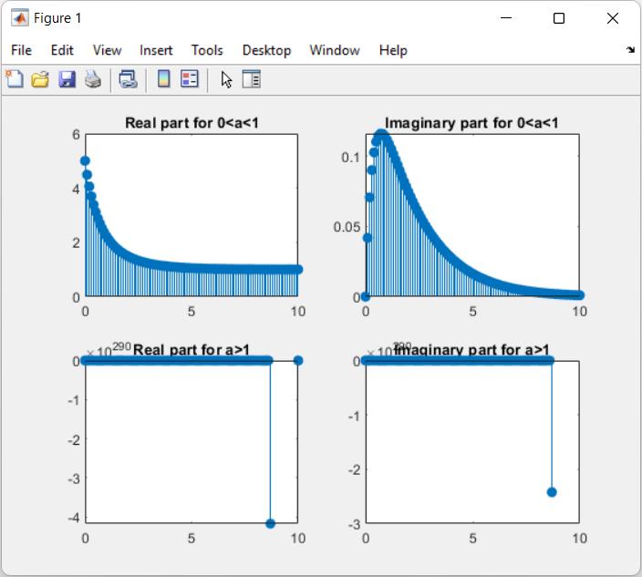

**Discussion and Conclusion:**

MATLAB can analyze as well visualize a complex number.

## Task # 09:

Plot the discrete signal x=a^|n| for n ranging from ‐10 to 10. Draw two subplots for 0<a<1 and

a>1.

**Problem Analysis:**

We require plotting of discrete signals sometime. We perform that in MATLAB.

**Algorithm:**

* Enter the discrete signal.
* Plot it.

**Code:**

*n=-10:0.1:10*

*a1=0.5*

*a2=2;*

*x1=power(a1,abs(n))*

*x2=power(a2,abs(n))*

*subplot(2,1,1)*

*stem(n,x1,'filled')*

*title('Discrete signal for 0<a<1')*

*grid*

*subplot(2,1,2)*

*stem(n,x2,'filled')*

*title('Discrete signal for a<1')*

**Code SS:**

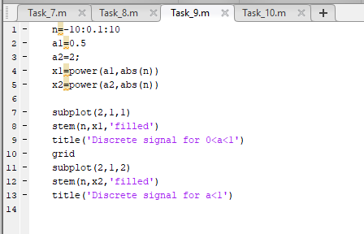

**Output / Graphs / Plots / Results:**

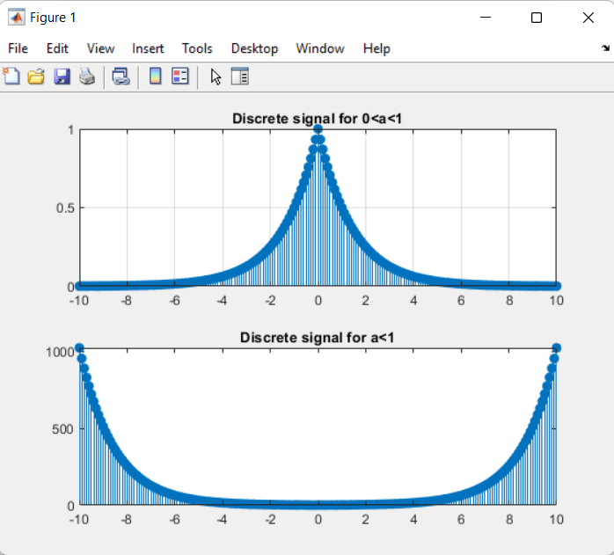

**Discussion and Conclusion:**

MATLAB can analyze as well visualize a complex number.

## Task # 10:

a) Generate the signal x(t) = Ae(jωt + π) for A = 3, π= ‐0.4, and ω = 2π(1250). Take a range for t

that will cover 2 or 3 periods.

b) Plot the real part versus t and the imaginary part versus t. Use subplot(2,1,i) to put both

plots in the same window.

c) Verify that the real and imaginary parts are sinusoids and that they have the correct

frequency, phase, and amplitude.

**Problem Analysis:**

Apart from other signals, we can also plot the complex signal (real and imaginary plot)

**Algorithm:**

* Enter/generate the complex signal
* Plot its real and imaginary parts

**Code:**

*t=0:0.04:4;*

*A=3;*

*pi=0.4;*

*w=2*pi*(1250);*

*x=A*exp(i*w*t+pi);*

*figure(1)*

*plot(t,real(x),'-m')*

*title('Real part')*

*xlabel('Sample Number')*

*ylabel('Signal Amplitude')*

*figure(2)*

*plot(t,imag(x),'-m')*

*title('Imaginary part')*

*xlabel('Sample number')*

*ylabel('Signal Amplitude')*

*figure(3)*

*subplot(2,1,1)*

*plot(t,real(x),'-m')*

*title('Real part')*

*xlabel('Sample Number')*

*ylabel('Signal Amplitude')*

*subplot(2,1,2)*

*plot(t,imag(x),'-m')*

*title('Imaginary part')*

*xlabel('Sample number')*

*ylabel('Signal Amplitude')*

**Code SS:**

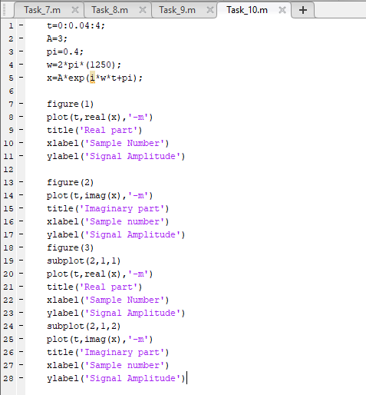

**Output / Graphs / Plots / Results:**

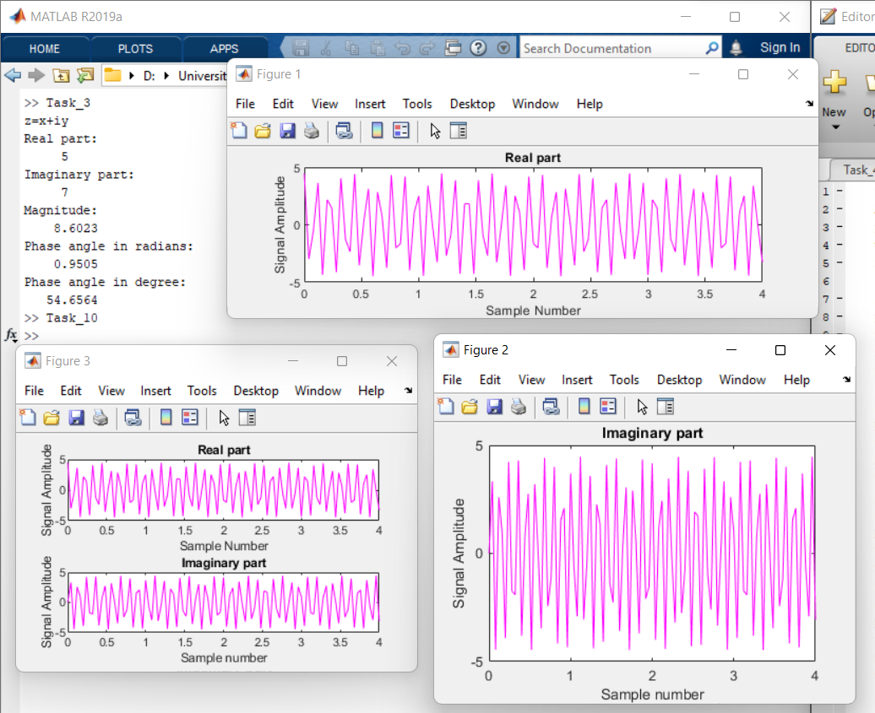

**Discussion and Conclusion:**

MATLAB can analyze as well visualize a complex number.